Algorithms and flowchart

The algorithm is a step-by-step instruction, guideline or rule to perform some action or reach the solution for given problem. Flowchart is one of the way to represent algorithm graphically, where graphical elements like boxes, squares, circles, and arrows connecting them represent flow of control. Every element can represent on step in the instructions.

Simplified flowchart elements:

Start

Circle.

[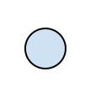](https://home.roboticlab.eu/_detail/method/algorithms/algus.png?id=en:programming:algorithms)

End

Filled circle inside bigger circle.

[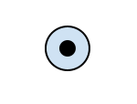](https://home.roboticlab.eu/_detail/method/algorithms/lopp.png?id=en:programming:algorithms)

Action or expression

Rectangle. Inside rectangle a name of the action, name of the sub-routine or short description can be written. Similar actions can be included into one general action.

[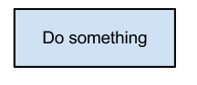](https://home.roboticlab.eu/_detail/images/programming/algorithm_action.png?id=en:programming:algorithms)

Sequence

Arrow, by pointing next activity.

[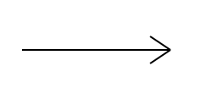](https://home.roboticlab.eu/_detail/method/algorithms/nool.png?id=en:programming:algorithms)

Condition / Decision

Diamond (rhombus). Inside diamond is a logical expression and in most cases two arrows are drawn out from diamond. One is when logical expression results True (Yes/1) and other when expression result is False (No/0). Always both arrows have to be labeled. In special case only one arrow can be used as output from diamond. The case is when logical expression can clearly result only one solution, e.g. True. This is the case where for example endless cycle is used in program code (e.g. *while (true)*).

[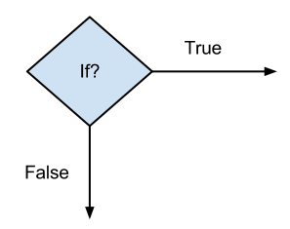](https://home.roboticlab.eu/_detail/images/programming/algoritmid_if.png?id=en:programming:algorithms)

Data exchange

Trapezoid. Inside trapezoid a name or activity is described. In robotics it is usually used to communicate with sensors and user. For simplification also normal rectangle action can be used instead of trapezoid.

[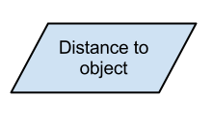](https://home.roboticlab.eu/_detail/images/programming/data_exchange.png?id=en:programming:algorithms)

Examples

Drawing flowchart diagrams one can use common office suits like MS Word or MS Excel or OpenOffice/LibreOffice Writer or Calc but better results can be get by using special programs like MS Vision, OpenOffice/LibreOffice Draw, Google draw or some special diagram creating software.

Flowcharts describing microcontroller software usually do not have ends, instead whole main activity in an endless cycle. The exit condition of the endless cycle will never be true and therefore this is the case where condition block (diamond) can be represented only on exiting arrow. Condition itself can be notes simply True or 1. Creating diagrams it is important to keep in eye on the fact that if the program has forks, it can be done only through the diamond object. Junctions (two arrows are joining) can be described by special symbol, but in simple cases, one may simply have an arrow point to another arrow instead.

Following examples illustrate the use of flowchart elements for describing simple algorithm. First example is simple routine by describing one-way flow without any cycle or decision points.

[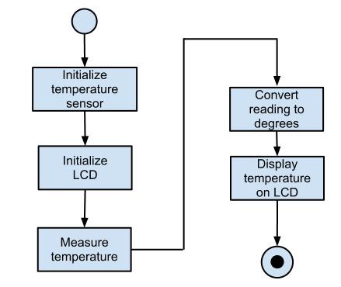](https://home.roboticlab.eu/_detail/images/programming/algorithm_example1.png?id=en:programming:algorithms)

Following example describes a system which detects 1 m area and if an object entering into inspected area an alarm is triggered for a 10 seconds. Alarm is working until the object is left from the inspected area.

[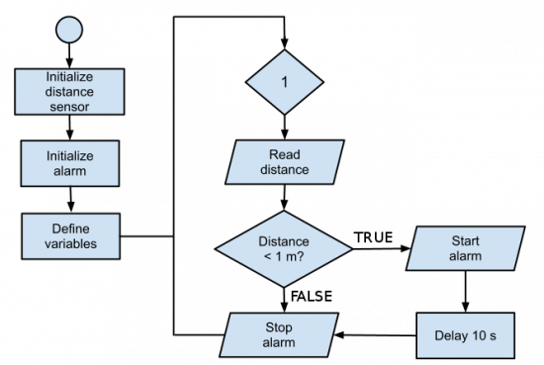](https://home.roboticlab.eu/_detail/images/programming/algorithm_example2.png?id=en:programming:algorithms)

<https://home.roboticlab.eu/en/programming/algorithms>

# Flow Chart

You are here:

1. [Home](http://www.robogalaxy.com/)

1. Flow Chart

A flowchart is a type of diagram that represents an algorithm or process, showing the steps as boxes of various kinds, and their order by connecting these with arrows. This diagrammatic representation can give a step-by-step solution to a given problem.

In programming world, flow Charts are used to help programmers in the early stages of programming. They are very useful when programming because they allow the programmer to set out, in a very simple way the sequence that he/she wants for each line of the program.

Robot software is the coded commands that tell a mechanical device what tasks to perform and control its actions. It’s a good idea to chalk out a logic flow diagram of what you need your robot to do; it will provide you a guideline when you program your creations. Engineers use it all the time to help them in their work.

A typical flowchart contains many symbols (building blocks), and most common symbols are depicted in below image.

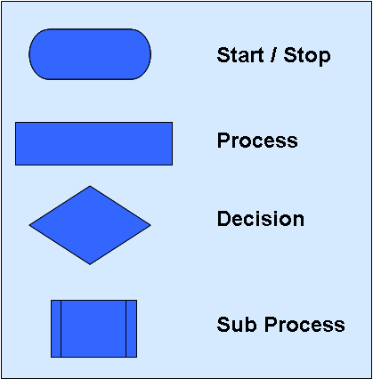 This is a flow chart representing a simple scenario:

- Robot moves forward for 5 seconds

- Robot moves backward for 2 seconds

- Robot turns left

- Robot moves forward for 3 seconds

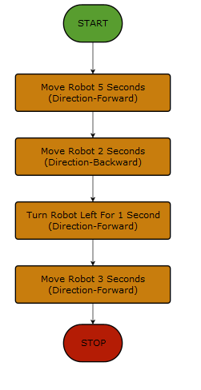

**Important Tips:**

-Flowchart should be clear, neat and easy to follow

- Flowchart should be un-ambiguous

- Usual Direction of the flow of a procedure or system is from left to right or top to bottom

- Only one flow line should come out from a process symbol

- Only one flow line should enter a decision symbol

- Write within standard flow chart symbols briefly

- If the flowchart becomes complex, it is better to use connector symbols and sub-process

<http://www.robogalaxy.com/flow-chart>